# Back to Thels Dorei

A lot has happened in the short week that you’ve been in Mt. Condor. You started your adventure meeting Thu’mer, Nasoj’s old friend from the fighter’s guild. You also met up with Rurik and Bearn, whom you saw or met in Swallow’s Song. Rurik over exaggerated Vahalla’s abilities and she became known as Vahalla WraithSlayer amongst the dwarves.

Elena was able to give the ring back to Ayana, who had given birth to a beautiful elven son named Glynvalur. It should be noted that Elena still has her baby owl, Ambrose.

Nasoj found that he had a daughter named Arys with an old lover, Rain.

During your time in the mountain, you entered the temple of the stone men, where you fought a Medusa and Nosaj had his hand turned to stone. Rurik met his end there.

You also fought a crazed Stone Giant in the underdark, nearly dying, and lost 2 dwarven companions. You met a crazy wizard named Patches and his familiar pseudodragon, Puff.

You accompanied Patches to the town of Water Reaper where you fought a Siren.

Back in the mountain, you met up with Ella and Kallista.

On a full moon night, Nasoj turned into a wererat and attacked both Arys and Rain. Both are alive, thanks to Patches.

Once Patches was able to cure Nasoj’s stone hand and was able to provide an amulet to keep his lycanthropy in check, you all headed to the top of the mountain with Ella and Kallista to retrieve a Talos relic.

You have decided to leave the mountain immediately. You are undecided if you are going to try to take Ayana back to Thels Dorei.

**What do you do?**

The weather is slowly starting to turn on your journey back. You arrived in the mountain at the end of summer, and you can feel the chill of autumn fall upon you. The leaves in the forest are still nearly all green, but the yellows and oranges and reds are beginning to show.

The walk is rather uneventful, but the children/child seems to enjoy being out of the dark, dwarven caverns.

Night begins to fall as you’re a little less than halfway back to Thels Dorei; having the babies is slowing down your trip. The mothers, especially, are tired from walking and would like to break to feed their children.

**What do you do?**

## Night Hag/No food

The night is quiet as you stumble off into sleep.

IF decided to stay guard: D15 constitution check = fall asleep

Try as hard as you might, you just cannot stay awake…

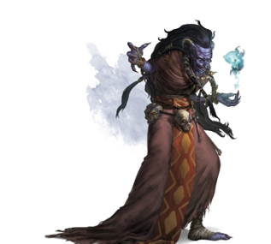Optional (if someone stayed awake): a gruesome woman wonders into your camp. Her purple skin and devil horns make your skin craw. Long nails double as claws off the beings slender hands. She is wearing skulls around her waist as a haunting belt.

**What do you do?**

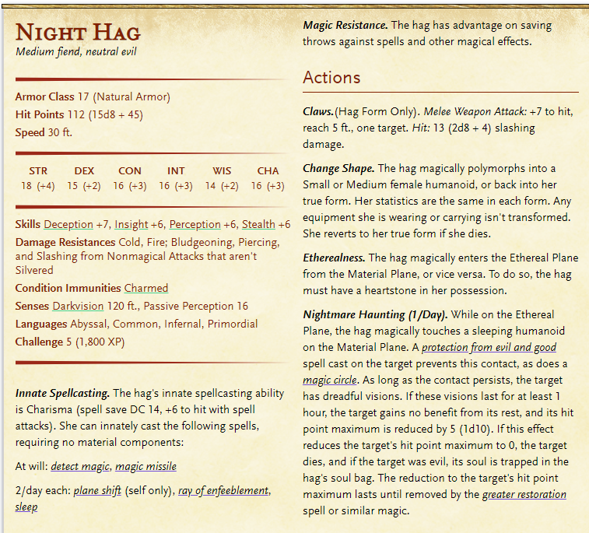She has come to take your food. If you give it to her, she will give you the power to bring 1 person back from the dead within 10 minutes of death.

If they say no, she will threaten them. If they still say no, she will fight them. The rest are in a magical sleep. Before you die, she will offer you the same deal, but only 2 minutes of death. If you still continue to fight, she will probably kill you.

Otherwise, you awake in the morning to find all of your food has been taken. All of your other items are still present, but every other bit of food is gone.

**What do you do?**

### Optional Hunting

Survival check (DC depends on how specific they want) to find and follow tracks

Stealth check (DC depends on animal) to sneak up OR

Dex check for archery

Successful stealth => advantage on attack roll

Unsuccessful stealth => depends on how bad, but either no attack, disadvantage or normal

If you don’t kill it, it bolts

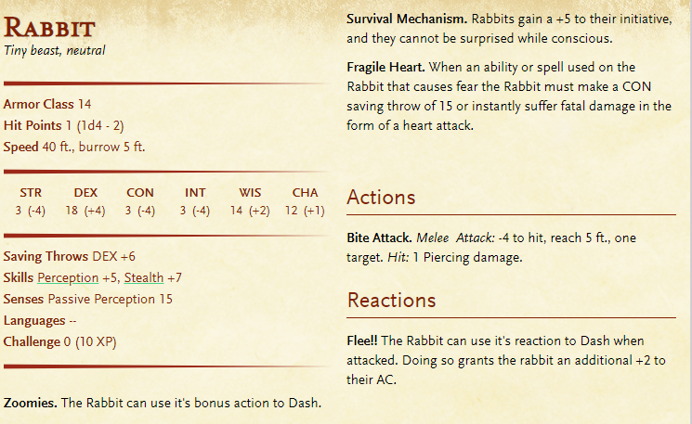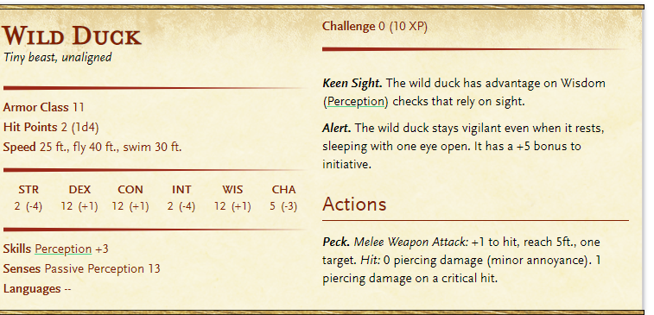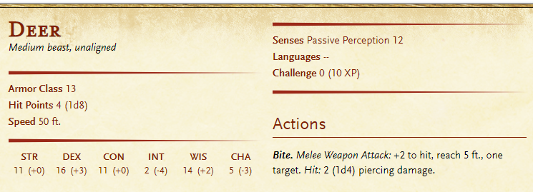

**Fishing**

DC 18 survival to catch a fish with a makeshift fishing pool or whatnot.

## Continue On

The day is growing long as your bellies are empty. Glyn is particularly hungry but is behaving very well. Raeya is still breastfeeding so Arys is hungrier than usual but has still been fed. Raeya is concerned for the rest of the day, however.

[owl] flies in and drops a dead mouse at your feet. It looks in bad condition and is very small.

**What do you do?**

Keep walking

## Optional Ogre Tic Tac Toe

Suddenly, the smell of boiling stew fills your senses.

**What do you do?**

Through the bushes, you see a giant but very alive ogre standing in a small clearing. There are large black stones in a pattern on the ground, but you can’t quiet see the pattern….

Near the opposite side of the clearing from where you are, you see two things: 1) a huge pot of soup that smells enchanting. 2) a dead Ogre who has had his head bashed in and arm chopped off.

**What do you do?**

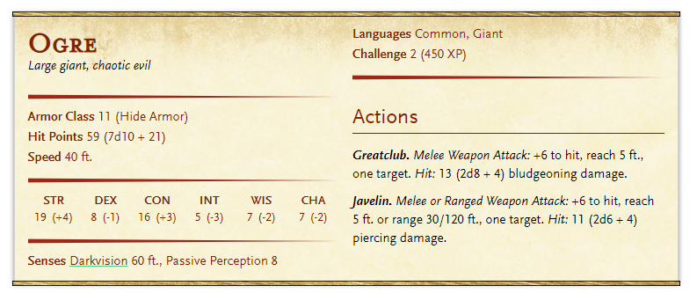

If the ogre sees you, it challenges you to play tic tac toe with it.

If you win, he will give some of his ogre soup.

If you lose, someone has to stay with him to keep playing tic tac toe indefinitely.

Glyn starts crying at the smell of food. His empty stomach yearning for the ogre soup.

If you play: Ogre plays with boulders. What do you play with?

If you lose, Ogre demands best 2/3. Players don’t know that ogres are weak.

Finish game/get food/etc.

Continue walking.

**Did you want to do anything?**

Back in Thels Dorei, Kastor is incredibly grateful to have Ayana and her baby safely returned to the elven village. He is incredibly thankful, but still doesn’t seem to like you.

* Staff of the Python (Druid, Cleric or Warlock only) (requires attunement)
  + Throw on ground and will turn into Giant constrictor snake
  + Must say command word
  + Mentally command snake within 60 ft
* Javelin of Lighting
  + When thrown and say command word, it turns into a lightning bolt up to 120ft.
  + Javelin damage + 4d6
* Bracers of Archery
  + Gives proficiency in bows
  + +2 to damage rolls with archery weapons
* Manual of Bodily Health
  + Talks about health and diet tips
  + Read for 48 hours within 6 days or less and Const score +2 (not mod)
  + Maximum for Const +2 (not 20 anymore, but 22)
  + Loses magic but can be reused in 100 years.
* 50gp (all they have)

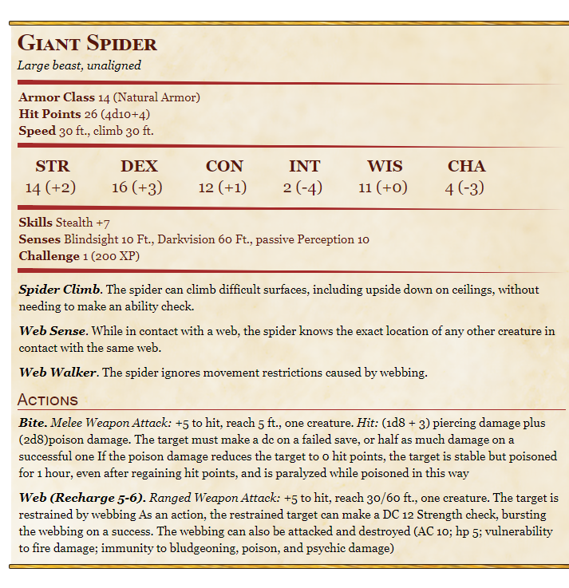

Ayana asks her g.gpa if Elena can stay and live as a celebrated hero for her efforts to keep Ayana and Glyn safe. He agrees.

**What do you do?**

## Skip Thels Dorei

Same stuff, except they will come across a giant spider’s web, and must fight a couple giant spiders.

# To Pixie Gardens

The hike out of the forest is long and tedious. The absence of mysterious mist and haunted mansions isn’t unnoticed by you, but greatly appreciated.

The birds chirp in the trees happily, but stop anytime Ambrose flies nearby.

The sunlight dances through the canopy in warm ribbons, illuminating the path in front of you.

**Want to do/talk about anything?**

Your journey back to the Serenity Gardens is as peaceful as you could wish for. The tall grass brushes your knees as you enter the heart of the plains. Night begins to fall as you arrive in the quiet village.

The village has been changed. Where beautiful flowers once danced in the moonlight, twisted weeds now grow. The silvery water of the pond has turned a dull, muddy brown. The smell of roasts and stews being cooked is absent, and it doesn’t appear as if villagers are in their homes.

You arrive at the visitor’s cottage and realize that it still only has 2 sets of twin sized bunk beds, with clean white sheets. The same clean pot continues to hang over a small fire place.

**What do you do?**

# The Pixie Garden

**To Pixie Garden**

As you continue down the path. You see the familiar scene of flowers. About 2 hours in you start to see rosebushes of usual size. You remember you are about 2 hours away from the Rosemar patch.

As you approach the Rosemar patch, you see a bright light whizzing around patiently.

**What do you do?**

The pixie is not Basil. Instead, a slightly taller, male pixie stands in front of you. His clothing is brown, as well as his eyes and hair. His skin is a copper brown color.

He asks you to come with him

The pixie is Styx. He is Basil’s fairy love.

A dark magic has been bleeding into the land. Basil and some other faeries went to Feywild to ask the King to help them understand and fight the magic. Basil had told him about your party, and said that you might one day come back, so he’s been waiting for you, since he really can’t do anything else.

He asks if you’d be willing to help. He tells you there are a lot of rare things in Feywild that most adventures don’t get to see. Kallista and Ella aren’t particularly excited about going, but will agree.

Try to get the relic from Nasoj and head back rather than go with them.

If you decide to go: All the pixies bring you to a large mushroom circle, large enough for all of you to stand in. As you wait, a faint hum starts to vibrate the air around you and the pixies begin to glow. Below your feet, the group begins to turn into what looks like a mixture of pastel colored metallic liquid mixed with glittery lights. The world around you starts to become immersed in this thick mixture. The realm as you know it disappears.

As you step into the mushroom circle with Styx, your pulse begins to race. The world around you begins to disappear in a mixture of metallic, glittery colors that weave in ribbons all around you.

# Feywild

As your vision begins to clear, you realize you have been transported to a land of never ending twilight. The horizon in front of you glows a vanilla pinkish-purple hue and bleeds into a beautiful array of teals of sapphire blues. As the sky pushes away from the set sun, it turns blacks and is decorated with greenish-yellow nebulas and purple starlight. Behind you, a giant planet has replaced the moon, glowing a beautiful blue and purple luminance, especially around it’s rings. In this magical world, the gravity is not affected.

The mushroom circle around you has remained as a gateway back to the material realm.

Outside of the circle, the largest mushrooms you’ve ever seen stand taller than trees where the silent plains once were. A bustling natural village has replaced the Pixie garden. Some of the mushrooms have been carved out and small beds have been made out of straw inside them.

Strange creatures that you’ve only heard of in fairy tales walk around, with their human torsos and goat-like legs. Horns of different shapes and sizes protrude from their heads. The village itself looks fairly large, possibly housing 100 satyrs.

The city is Methos.

**Male Names**: Adrastos, Aeolus, Brontes, Castor, Cephalus, Glaucus, Helios, Iacchus, Kreios, Lycus, Melanthios, Okeanos, and Proteus.

**Female Names**: Acantha, Astraea, Briseis, Clio, Erato, Harmonia, Ianthe, Jocasta, Melete, Phaedra, Phoebe, Selene, and Tethys.

Styx explains the Feywild.

* It is a copy and overlap of the material world
* It has exaggerated features of the material world. Cities in the material world are mirrored as cities of different types here. Mountains are mountains of different types, etc.

They believe that you should go to the city of Stardust, which is half a day’s walk south from where you are. You realize that it’s probably in the same place as Silver Rose.

**What do you do?**

Show shops. www.dndShops.club/Methos.html

You notice a fiery energy burning in you. The magic of Feywild is amplifying your every emotion, exaggerating both your greatest and worst traits. Confidence becomes narcissism. Fondness becomes uncontrollable love. Jealousy become homicidal greed. Content becomes full-body ecstasy.

You wonder how these heightened emotions will affect your actions and reactions in this world *cough cough*

**What do you do?**

The walk is enchanting and magical. The windrazor grass hums whenever the wind blows over it, adding a sweet melody to your journey.

About 2 hours into your walk you smell a faint sweet smell (that is strong to Nasoj) coming from somewhere very close to the east.

**What do you do?**

If they investigate, they start to notice the tops of some of the mushrooms are eaten away by human sized mouths.

They come across a small colony of caterpillar people! Some are fuzzy and come in green and black, while others are smooth and are blue or orange. The ‘feet’ on them are actually hands (Absolem in Alice in wonderland). You see them eating away at the mushroom tops. They do not seem to notice your presence.

‘These are the cater-people’ Basil explains. “They’re intelligent, but not very intelligent. Like ogres. Be careful though, they can spit up a sweet-smelling poison that will get you very high. Some fey creatures like to collect it and drink it at parties. It’s too strong for us Pixies, though.”

If the poison is collected by Elena, then it will intoxicate any fey creature, but will put any non-fey into a coma.

**What do you do?**

As you continue to Stardust, the mushrooms start to get smaller as a whimsical forest begins to sprout around you. Dark oak trees become thicker and thicker and have toadstools and vines residing on them. You run into a small stream that doesn’t exist in the material plane, except as the road leading from Silver Rose to the Serenity Gardens. The stream parts the forest and glows a crystal blue color, providing bright light as you travel through the thickening forest.

Glofish of every color are swimming beneath the water while white lily pads with purple flowers float along. Rainbow shellfish are occasionally found in clusters int the river.

*moon pearls* d20 # of pearls (1d6 color x 1d4 size)

D1 – blue (10 gp)

D2 – green (10 gp)

D3 – pink (10 gp)

D4 – white (5 gp)

D5 – black (20 gp)

D6 – Rainbow (1,000gp)

D1 – Tiny (x.5)

D2 – Standard (x1)

D3 – Large (x1.5)

D4 – Huge (x2)

D1-d16 1 pearl

D17-d19 2 pearls

D20 5 pearls

On the other side of the narrow river, you notice a decent size tree with a large hole in it.

**What do you want to do?**

If you cross the river: DC 15 to not slip (slippery puddle by boggle). A stifled laugh echoes from behind the tree.

**What do you do?**

## Boggle

Boggles were made where the fey world touched the real world and there was an extremely lonely and/or abandoned intelligent being on the other side.

Boggles can secrete 1) a sticky oil that requires strength to get out of or 2) a slippery oil that requires a dexterity check to hold on to.

Limbs can stretch up to 2x size and contract to ½ size.

Boggles can make a puddle of either and it lasts 1 hour.

Good with perception, slight of hand, stealth, darkvision, and smell.

Really high dexterity and constitution. Very low strength.

Dimensional rift action, tunnel 30 feet that only they can move through/see through/bring items through, but needs a frame (a window, hole, basket opening, etc) to go through. Lasts 1 turn.

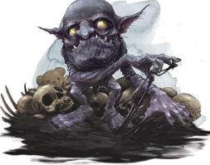Styx sighs in annoyance.

“Is a boggle….” Styx announces.

A tiny creature, maybe 3 feet tall peeks out around the tree. It’s head is large and nearly 2x the size of its body. It’s purple, wrinkled skin is moist with some sort of oil, presumably what you just tripped in. It’s giant yellow eyes stare at you.

It giggles and hides behind the tree.

**What do you do?**

It continues to harass you in various ways (i.e. dim rift to push your knee out from behind you, sticky oil, slippery oil, pick pocketing, etc).

Even if you leave the Boggle tries to follow you. It seems to like you but stays hidden amongst the trees.

As you continue to walk, you realize you’re not sure how long you’ve been walking. For some of you, it feels like minutes, while others feel like days.

You finally come to an extreme drop off. Trees at the edge of the cliff hand on for dear life only by their roots. Others have crumbled and lead down towards the canyon’s surface.

As you look down, you notice the canyon extends miles below your feet, right where silver rose would be. However, in the center of the canyon, a giant clear staircase raises into the sky. The stone doesn’t resemble anything you’ve seen in your world

Torg can check if he knows what it is DC 20 (because its mystical) – he has Int(History Check) + proficiency x 2 (so history check + 4).

It is glass stone, found only in Feywild. It is as hard as diamond but has deep magical properties to it. It is easily enchanted to keep its form, and once enchanted, it is nearly impossible to disenchant. After 1000 years, nothing can disenchant the stone.

As you follow the spiral staircase up, you see something more wonderous than anything you’ve ever seen before. The stone from the canyon has broken from the earth and floated into the sky. You can only see the bottom of the floating stone.

On the other side of the canyon, several miles away, you can see the glimmer of something sparkling down from the floating rock, consistently.

“Up there!” the pixie yells and flies off in balls of light. You are unsure if he remembers that you cannot fly…

**What do you do?**

If you try to get down, you will surely fall. It is very steep and a very long way down.

A tiny rock hits Elena from behind. A familiar snicker rings from behind a tree behind you.

The tiny, ugly boggle dashes out from behind the tree, and runs full force into another tree. He disappears.

**What do you do?**

As you approach the area where the boggle disappeared, you notice the tree is discolored on in one, large area.

**What do you do?**

The trunk jiggles below your hand, similarly to a water bed. As you press harder, your hand pushes through the trunk, the opening changing size to fit your hand.

**What do you do?**

As you step through the hidden door, you find yourself falling!

The smooth rock acts as a slide as you zoom towards the bottom of the canyon. A layer of slippery oil coats the slide.

DC 15 Dex Check

On fail: You go flying in towards the bramble. Your clothes are torn a bit and you take 1d4 damage (1d8 if you crit fail)

On Success: You fall but quickly notice the bramble you are about to fly into. As you exit the rock slide, you are able to slow down enough to drop straight down into the clear patch beneath the slide. You quickly get out of the way.

The bramble bushes are thick and sharp.

*Perception Check*

Yet beneath the bramble, you can see a beaten path worn amongst the moss-covered ground.

You also notice the entrance to a cave. The boggle is standing in front of it. The cave mouth is covered in white and purple translucent crystals.

**What do you do?**

## Cave Path

The crystal is incredibly strong and would take a very long time to mine.

There is a stream running through the cavern walls; you can see it through the crystals.

Small glowing bugs seem to float through the cave, moving very slowly. They glow in colors such as pink, blue, purple, and white.

The ground is not covered in crystal. Instead it is a grainy sand-like substance of all the crystal colors. Worms that seem to glow green are moving through it, occasionally surfacing.

You come to a large cavernous room with a giant crystal mound in the center of it. The crystal looks like someone has been attempting to mine it; it is chipped in several places. On the top of the mound, there is a beautifully carved, but dull in color sword. It stands out in this colorful place.

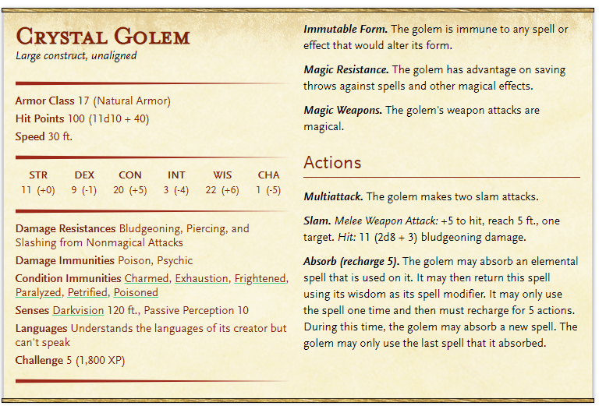

**Long Sword – Bane of the Fey**

Turns a beautiful purple black (show picture). Blade and hilt have been carved out of this crystal

+1 bonus to attack. Strong against fey (2x damage). Weak against undead (1/2 damage).

Glows bright purple when flighting fey. Turns gray if you hit an undead with it. If you kill an undead with it, it will break.

# HAG HOUSE – See Separate Guide

# Stardust

## Up the staircase

As you turn around, you see two very long chicken legs lift up the house and begin walking away. As you gaze up at this staircase, it seems to be never ending. The emotional pressure of Feywild is starting to weight on you. Some of you may believe you can conquer anything, including this staircase, with ease. Others may feel like its hopeless. You’ll never make it up.

**What do you do?**

As you make it to the top, you are greeted by a starlight sky. A bluish-marble surrounds the top of the staircase and is encased in the greenest grass you’ve ever seen. Eight buildings immediately surround the area.

* Ricochet Armament
* Epic Flail
* Rags to Riches
* Gnome Depot
* Violin Delights
* Eye of the Beholder
* A winery
* A florist

Surrounding that you notice 4 large buildings. Behind you, a temple stands. It seems to be a general temple for the Archfey. To your left is a tavern and inn. To your right, a large library. In front of you, you see a huge palace made of white marble. A long pond stands between it and you, surrounded by a royal purple marble rim.

All around you, various fey creatures are mingling. From faeries and sprites, to star elves, to satyr, you are enchanted by the beauty of the inhabitants. They seem intrigued and frightened and enchanted by your presence. Feywild doesn’t get a lot of non-fey visitors.

It is worth mentioning that the emotional infliction you are experiencing is as exhausting as anything else.

## The Temple

Some of them were powerful fey of many races, others were the awakened spirits of natural places such as forests or rivers, others the sentient incarnations of different types of animals, and others were noble eladrin so old and powerful that had transcended the bounds of mortality.

* Lurue the Unicorn Queen (battles with unicorn horn)
* Neifion, the Lord of Bats (controls bats)
* Oberon, the Green Lord (Titania’s Husband)
* Relkath of the Infinite Branches (Int, grows trees and turns people into them)
* Sarula Iliene the Nixie Queen (aquatic sprit queen)
* Titania, the Queen of the Summer Court
* Verenestra the Oak Princess (titania’s daughter, god of female fey, charm, beauty)

## The Town

The town has many citizens wondering around. In the immediate area,

1. you see a group of young elven girls standing around talking (the prince has disappeared. Who will Dame Gothel marry now!),
2. a shop keeper rushing a small rat out of his shop (talks about rat problem),
3. 2 young elven boys playing in the street (asks you for money to buy candy 2cp each). They boys say that a young bard used to give them candies and play his flute, but he hasn’t come around in a while. His music was amazing!
4. a well-dressed man asking frantically stopping people (asking for his son),
5. and a well-dressed pregnant woman sobbing on the temple steps.

### The stables

There is a stable in town that houses Pegasus and Unicorns. They will sell you baby ones and young adult ones. See website for pricing

### Rumpelstiltskin

* The woman who is sobbing says she is expecting her baby any day now.
* Her father, who is very poor and struggling to feed his family, was bragging to the nobleman’s father that she could turn straw into gold, attempting to arrange a marriage..
* The nobleman said if she could, he would introduce her to his wife.
* When the woman was thrown into room with a bunch of straw, she sobbed until a small imp appeared and asked her what was wrong. She told him, and he said he would spin the straw into gold if she gave him her necklace.
* The nobleman was quite impressed the next morning and said, “if she does it again, he would introduce her to his son.”
* The same thing happened the next night. She gave him her hairpiece, the only thing her mother had ever given her.
* She met the man’s son and fell in love with him. But was forced to do the same the next night.
* The imp wanted her first born.
* Now she is pregnant and hasn’t told her intended about the deal. The imp said if she could guess his name, he would leave her baby with her, but nothing she guesses is correct.
* Her fiancé is very rich and she offers you a reward for it.
  + In the book of fairy tales, it tells of an imp named Rumpelstiltskin who would trade services for children. If you can find the imp’s name in the book, and give it to her, you win.
  + 3000gp

### Pied Piper

* A man is looking for his son.
* Elven children have been going missing including her son. He says his family can pay you 1000gp if you can find his son!
* Walk around and learn:
  + A recent infestation of spiders and rats has plagued the city. This has never been an issue before (because of the darkness in feywild)
  + An elven bard has been enchanting the rats and spiders to the waterfall, to drown them, per order of the king.
  + The king refused to pay so the bard isn’t taking care of them anymore.
* Plot: The bard is luring the children away until he gets paid the 100gp he is owed
* “If you do not have my money, I do not have the time”

## The Palace

The frog is frantically trying to bounce towards the castle.

The palace is a beautiful white marble through and through. White sculpted columns support the interior while various colored marble status of elves and other fey creatures provide the room with a splash of color. A fountain carved from white marble protrudes from the floor about 9ft. The water is a clear teal color. Common elf servants are polishing the marble statues and floors. A large arch doorway stands open in front of you, and 2 white doors are on either side of the room.

1. Some of the elves are whipering to each other (talking about how the prince probably ran away to seek help from baba yaga. They won’t tell you any more info)
2. You hear whispers about how excited Dame Gothel is marry the prince, and how unfortunate it is that he is gone.
3. Someone directly says, “It’s been quiet without the prince around. He used to come sing to us. He had such a melodic voice”
4. Some are talking about how the prince wants to marry the princess in the tower, and he may have run away to see her. (5 miles away)

You meet up with Styx, and he and Basil are super excited to see each other. She explains the hag trapped them, etc. Styx says the king has been gone for a few days, out looking for his son.

**What do you do?**

### The Frog Prince

* The queen is distraught because her son (Flynn) has disappeared. She says he was due to be married but hated his bride. He had been begging his parents to let him marry another girl, but they refused. She offers a reward if you are able to find him.
  + An elven necklace of beauty. Valued at 4000gp
* Dame Gothel is talking to the queen and begs you to find her beloved prince
* His intended/Someone comments on how sweet his singing voice is. Its so melodic, it almost puts you to sleep.
* A maid is talking about how the elf maiden he wants to marry lives about 2 hours north of Star Dust in a remote tower of all places.
* Plot: The prince went to Baba Yaga for help, and she said she would help make sure he would never have to marry his intended. So, she turned him into a frog and stuffed him into a jar.
* Must also get Rapunzel to get true love’s kiss.

### Rapunzel

* Prince’s true love is stuck in a tower. A witch has kidnapped her there for her beauty. She will let down her magical hair, etc.
* Plot: Go to rescue the girl but the witch attacks you at a random point. If you win, a magical door appears. She will go with you to see her prince/kiss him.
* She gives you a shawl she has sown with thread made from her golden hair (gross). Wearers who are singing will regain HP. Regains +1 HP per minute, up to +5 hp per hour.

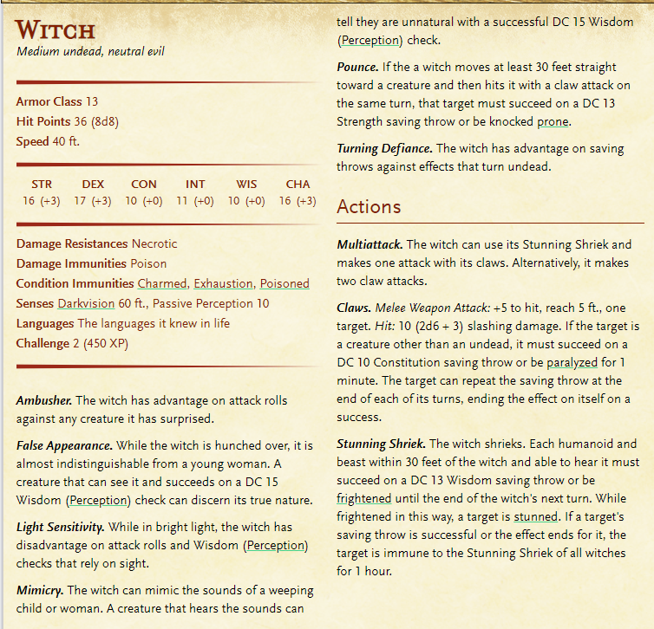

### The marriage

The prince insists he marry Rapunzel, but they insist he marry Dame Gothel. She isn’t as pretty, but her magic is well-regarded. She seems to be missing, though….(i.e. she was the witch).

The prince thanks you for restoring him.

### The King

The king has returned upon hearing his son is back.

# LEAVING READ ME

LEAVING: memory loss DC 10 wisdom save (fey ancestry automatically passes)

Timewarp roll dice: 1-2 days become minutes, 3-6 days become hours, 7-13 no change, 14-17 days become weeks, 18-19 days become months, 20 days become years

s